GRADE 7 ACCELERATED · UNIT 2 · LESSON 3
Cube Values
Worksheet 7A.02.03 ANSWER KEY

1. Complete the table. Each volume is the side length multiplied by itself three times.
Side s | 1 | 2 | 3 | 4 | 5
Volume s³ | 1 | 8 | 27 | 64 | 125
Side −s | −1 | −2 | −3 | −4 | −5
Volume (−s)³ | −1 | −8 | −27 | −64 | −125

The bottom two rows are the point of the table: a negative side length is not a real box, but (−s)³ is a real number and it is negative. Squares never do this. Come back to it in question 13.
2. Find the volume of the cube shown.
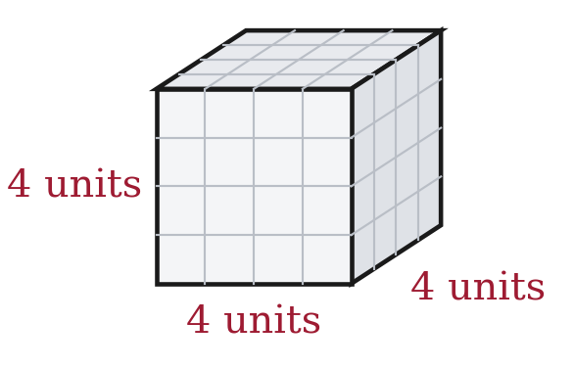
V = 4³ = 4 × 4 × 4 = 64 cubic units
A student who answers 12 has multiplied by 3 instead of cubing. A student who answers 16 has stopped after squaring.
3. A cube-shaped box has a volume of 125 cubic inches. How long is one edge?
5 × 5 × 5 = 125, so each edge is 5 inches.
125 is the largest perfect cube the Grade 8 FAST will ask about, and −125 is the smallest.
For questions 4 through 7, find the value.
4. 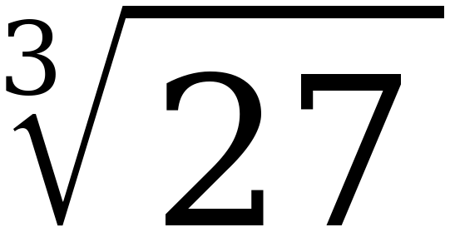
3 3 × 3 × 3 = 27

5. 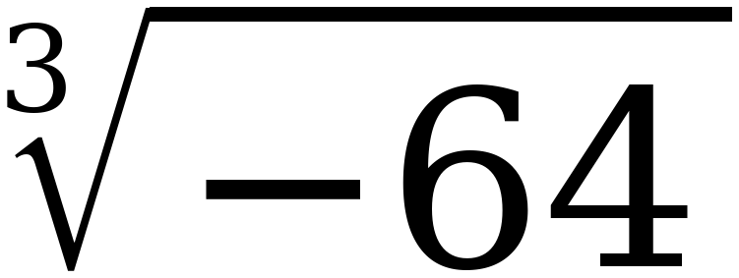
−4 (−4) × (−4) × (−4) = −64
Unlike a square root, a cube root of a negative number does exist. Three negative factors give a negative product.

6. 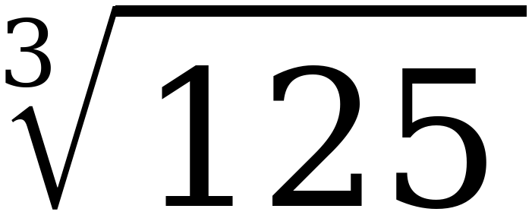
5

7. 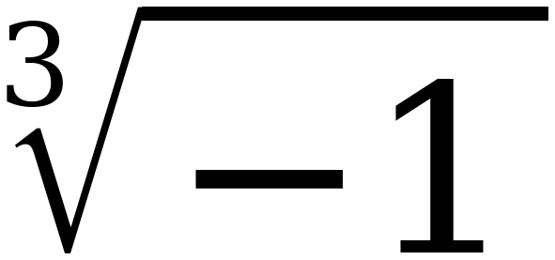
−1

For questions 8 through 10, find every real solution of the equation.
8. x³ = 8
x = 2 one solution, not two
(−2)³ = −8, not 8, so −2 is not a solution. This is the single most-missed idea on this benchmark.

9. y³ = −125
y = −5

10. n³ = 0
n = 0

11. Select ALL of the values below that make x³ = 64 true.
☒ | 4 | ☐ | −4
☒ | 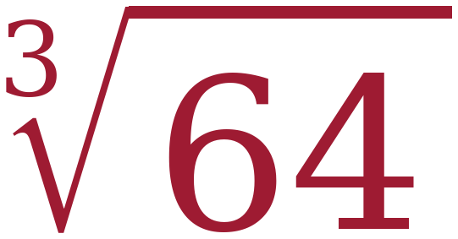 | ☐ | −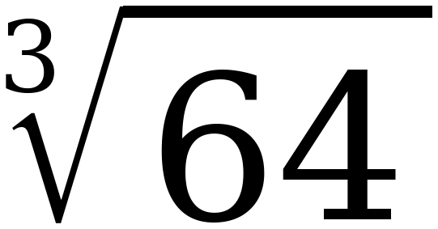
☐ | 8 | ☐ | 21⅓

Two of the six. This exact question appeared on the 2025 released items and 26% of students got it right — one of the six lowest scores on the whole exam. The trap is −4 and −∛64, both of which give −64. 8 is the square root of 64; 21⅓ is 64 ÷ 3.
12. Complete the table of values for y = x³. Then plot the five points on the grid.
x | Substitute into y = x³ | Coordinates (x, y)
−2 | y = (−2)³ = −8 | (−2, −8)
−1 | y = (−1)³ = −1 | (−1, −1)
0 | y = (0)³ = 0 | (0, 0)
1 | y = (1)³ = 1 | (1, 1)
2 | y = (2)³ = 8 | (2, 8)

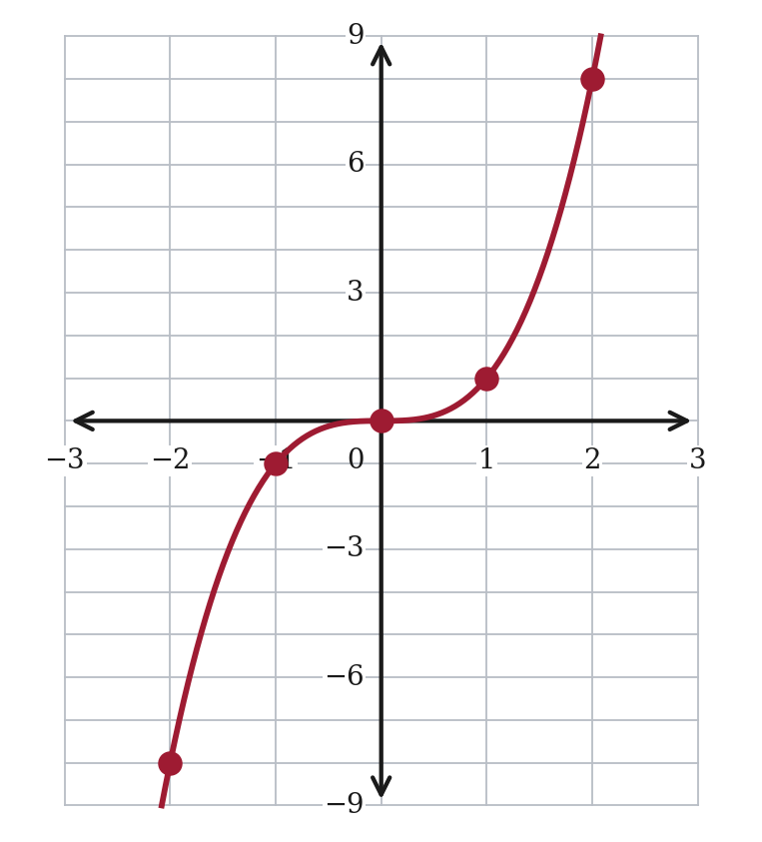
Compare with the graph of y = x² from Lesson 1. That one stayed on or above the x-axis. This one crosses it, because cubing a negative gives a negative.
13. The equation x² = 64 has two solutions, but the equation x³ = 64 has only one. Explain why.
x² = 64 has two solutions because 8 × 8 = 64 and (−8) × (−8) = 64. Two negative factors multiply to a positive.
x³ = 64 has one solution because 4 × 4 × 4 = 64, but (−4) × (−4) × (−4) = −64. Three negative factors multiply to a negative.
So a positive number has two square roots but only one cube root.
The point needs the count of negative factors, not just the answers. A student who says “because cubes are different” has not explained anything.
STRETCH. The two questions below use cubes larger than the Grade 8 FAST will ask for. The method is identical — only the arithmetic is bigger.
14. 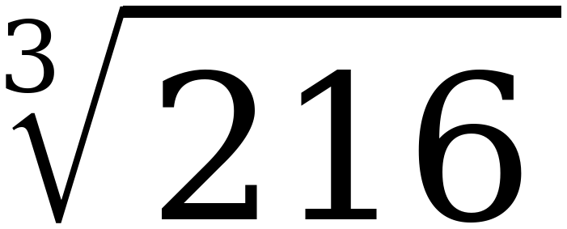
6 6 × 6 × 6 = 216

15. m³ = 343
m = 7 7 × 7 × 7 = 343
Still one solution, for the same reason as question 8.

